CIS 11 Lab 6: Fibonacci numbers

In this lab, we will create a program for Fibonacci numbers.

Fibonacci numbers
The Fibonacci numbers exhibit a numerical pattern which describes an amazing variety of phenomena, in mathematics and science, art and nature. With mathematical ideas, Fibonacci sequence leads to the golden ratio, spirals and self- similar curves, have long been appreciated for their charm and beauty in the world of art and nature.
The Fibonacci sequence is named after Italian mathematician Leonardo of Pisa, known as Fibonacci; who introduced the sequence to Western European mathematics, although the sequence had been described earlier in mathematics in India.
Applications of Fibonacci numbers include computer algorithms such as the Fibonacci search technique and the Fibonacci heap data structure, and graphs called Fibonacci cubes used for interconnecting parallel and distributed systems. They also appear in biological settings, such as branching in trees, phyllotaxis (the arrangement of leaves on a stem), the fruit sprouts of a pineapple, the flowering of an artichoke, an uncurling fern and the arrangement of a pine cone's bracts.
See video: https://www.ted.com/talks/arthur_benjamin_the_magic_of_fibonacci_numbers?language=en
The Fibonacci numbers are
0, 1, 1, 2, 3, 5, 8, 13, ... (add the last two to get the next)
0 + 1 = 1
1 + 1 = 2
1+ 2 = 3
2 + 3 = 5…
By definition, the first two numbers in the Fibonacci sequence are either 1 and 1, or 0 and 1, depending on the chosen starting point of the sequence, and each subsequent number is the sum of the previous two.
The sequence F_{n} of Fibonacci numbers is defined by the recurrence relation (an equation that recursively defines a sequence or multidimensional array of values, once one or more initial terms are given):
F_{n}= F_{n-1} + F_{n-2}
with seed values: F₁ ₌ 1 and F₂ = 1
or F₀ = 0, F₁ = 1

LC-3 Programming

Problem Statement
- Write a program in LC-3 assembly language that computes F_{n}, the n^{th} Fibonacci number.
- Find the largest F_{n} such that no overflow occurs, i.e. find n = N such that F_{N} is the largest
Fibonacci number to be correctly represented with 16 bits in two’s complement format.

Input
The integer n is in memory location x3100.

Output
F_{n} is in x3101
N is in x3102
F_{N} is in x3103

Example:
Starting with 6 in location x3100 means that we intend to compute F₆ and place that result in location x3101. Indeed, F₆ = 8. (See below.) The actual values of N and F_{N} should be found by your program and be placed in their corresponding locations.
x3100 | 6
x3101 | 8
x3102 | N
x3103 | F_{N}

- Write the pseudo-code for the Fibonacci program. The problem should be solved by iteration using loops as opposed to using recursion.
The pseudo-code for the algorithm to compute F_{n} is in listing 4.1. It is assumed that n > 0.
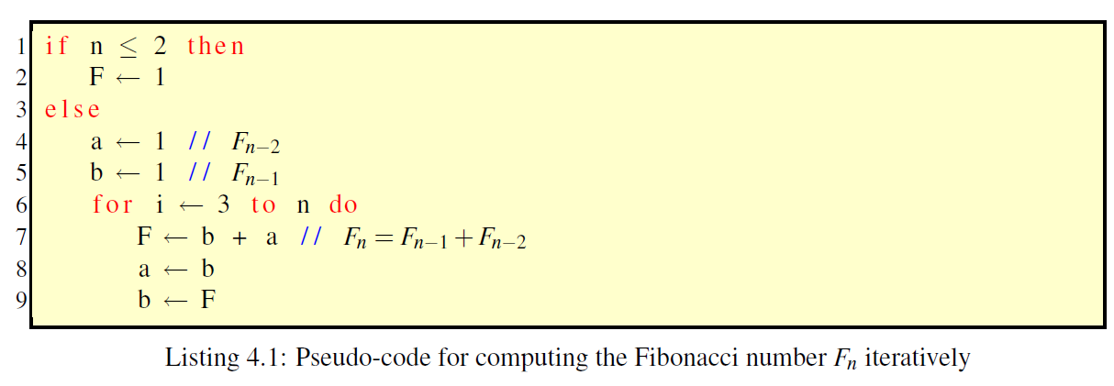
The way to detect overflow is to use a similar for-loop to the one in listing 4.1 on page 4–2 which checks when F first becomes negative, i.e. bit 16 becomes 1. See listing 4.2.
Caution: upon exit from the loop, F does not have the value of F_{N}. To obtain F_{N} you have to slightly modify the algorithm in listing 4.2.
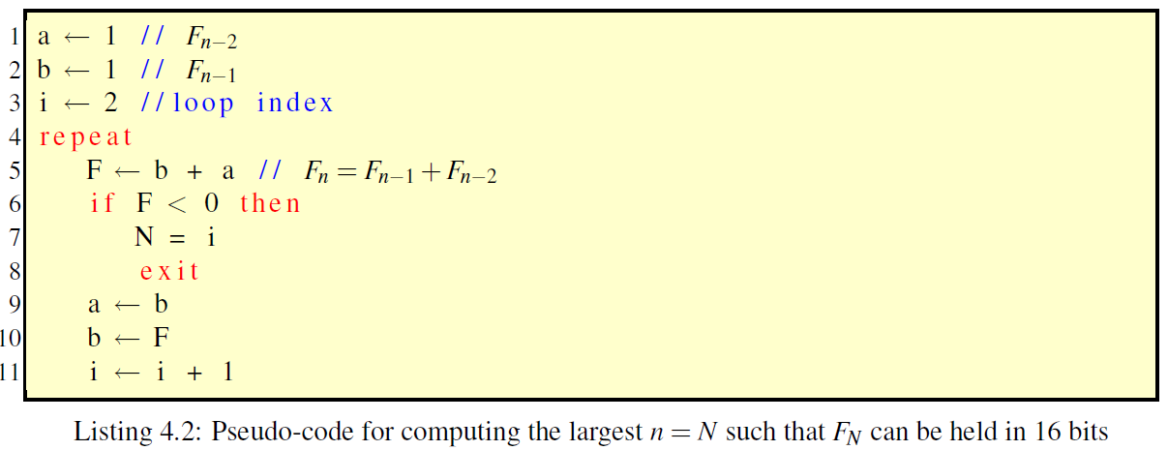

- Build an LC-3 program based on the pseudo-code. Provide the screen captures of a code in Editor and Simulator output.
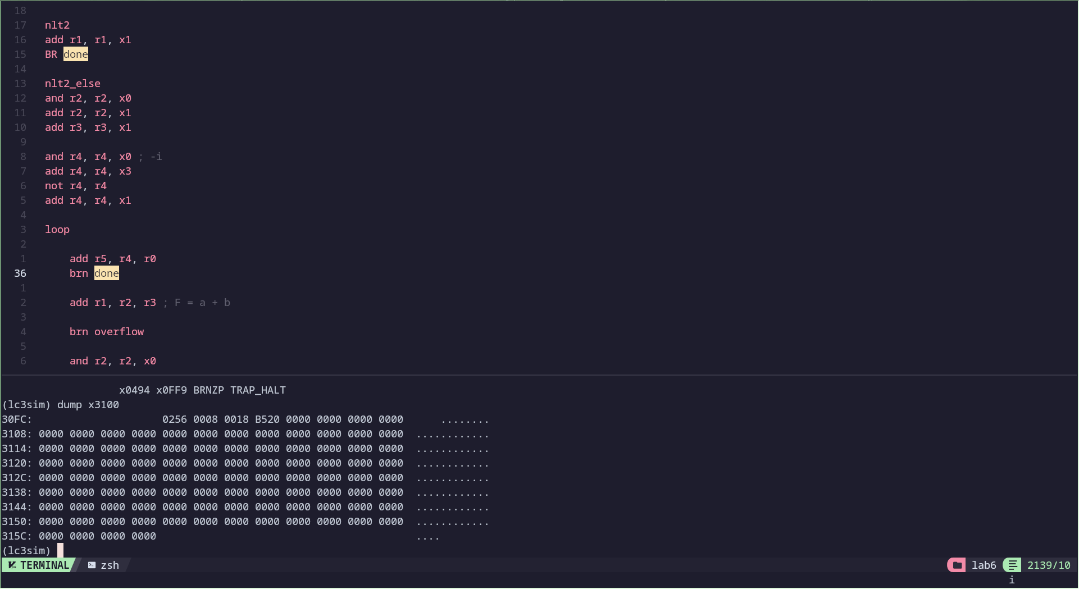
.ORIG x3000

ldi r0, n

; Clear registers
and r1, r1, x0 ; F
and r2, r2, x0 ; a
and r3, r3, x0 ; b
and r4, r4, x0

add r4, r4, x3
not r4, r4
add r4, r4, x1

add r2, r0, r4
BRn nlt2
BR nlt2_else

nlt2
add r1, r1, x1
BR done

nlt2_else
and r2, r2, x0
add r2, r2, x1
add r3, r3, x1

and r4, r4, x0 ; -i
add r4, r4, x3
not r4, r4
add r4, r4, x1

loop

add r5, r4, r0
brn done

add r1, r2, r3 ; F = a + b

brn overflow

and r2, r2, x0
add r2, r2, r3 ; a = b

and r3, r3, x0
add r3, r3, r1 ; b = F

add r4, r4, xffff ; i=i-1
br loop

overflow
not r4, r4
add r4, r4, x1
sti r4, oN
sti r1, oFN
halt

done
sti r1, Fn
halt

n .FILL x3100
Fn .FILL x3101
oN .FILL x3102
oFN .FILL x3103

.END

